EMPLOYEE LEAVE MANAGEMENT SYSTEM
Simple Project Report
Spring Boot REST API Project
Java • Spring Boot • REST API • JPA • H2 Database
Project Submitted by
RAGAPRABANJANI R
SUBARATHANA S
KAVISRIVYSYA C
VISHNU H

1. Project Overview
The Employee Leave Management System is a REST API application for managing employee details and leave requests. It provides a simple way to add employees, apply for leave, view pending requests, approve or reject leave, search employees, and maintain leave balances.
- Employee CRUD operations
- Leave application and approval/rejection
- Leave balance and leave history
- Employee search and department filtering
- Input validation and centralized error handling

2. Problem Statement
Managing employee leave manually can make it difficult to track requests, approval status and remaining leave. This project solves the problem by providing a centralized REST API where employee and leave information can be stored, searched and updated in a structured way.

3. Objectives
- Create, read, update and delete employee records.
- Allow employees to submit leave requests.
- Approve or reject pending leave requests.
- Deduct leave balance only after approval.
- View pending requests and employee leave history.
- Search employees by name and filter by department.
- Demonstrate a layered Controller → Service → Repository → Database design.

4. Technology Used
Technology | Purpose
Java 17+ | Programming language
Spring Boot 3.5.6 | Application framework
Spring Web / REST | API development
Spring Data JPA | Database access
Bean Validation | Input validation
H2 Database | Development/demo database
Maven | Build and dependency management
Postman | REST API testing
Eclipse | Java development and execution

5. System Architecture
The system follows a layered architecture. Each layer has one main responsibility.
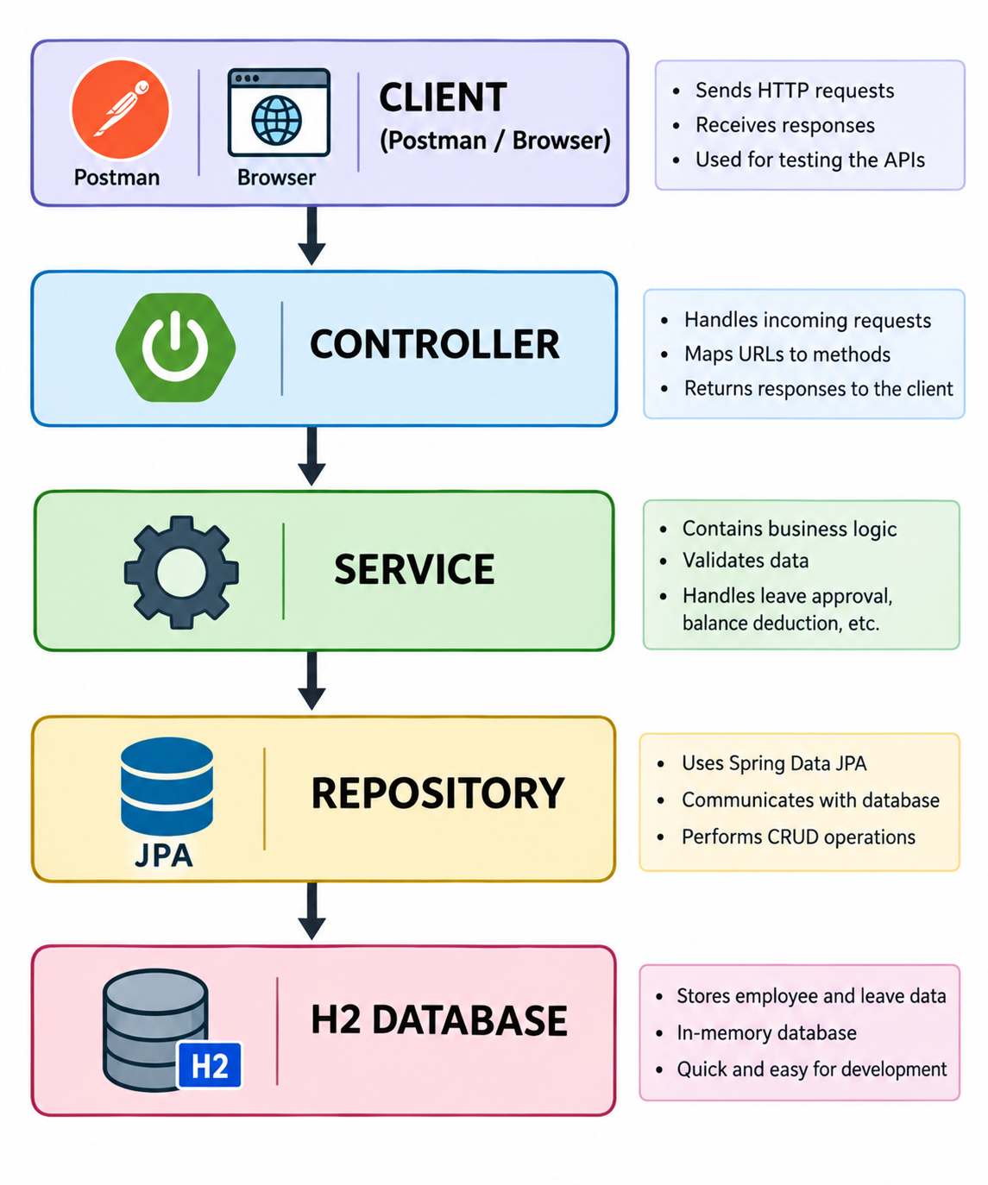
Controller – receives API requests and sends responses.
Service – contains business rules such as leave approval and balance deduction.
Repository – communicates with the database using JPA.
Entity – maps Java objects to database tables.
DTO – controls request and response data.
Exception Handler – returns consistent error responses.

6. Main System Flow
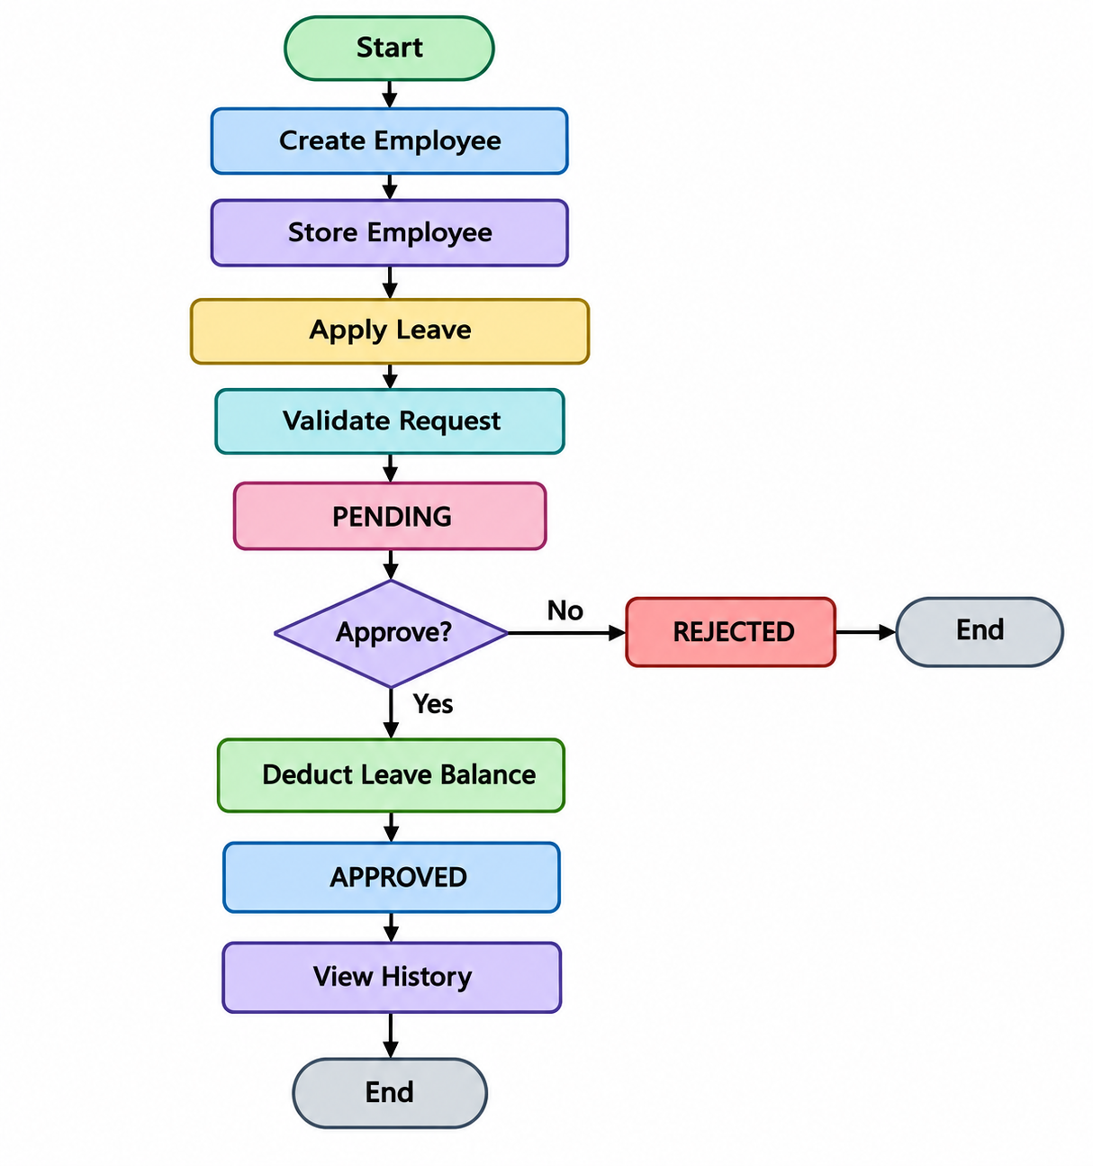

7. Database Design
The project uses two main entities. One employee can have many leave requests.
Entity | Fields | Relationship
Employee | id, name, email, department, leaveBalance | 1 employee → many leave requests
LeaveRequest | id, employee, startDate, endDate, reason, status | Belongs to one employee

8. API Endpoints
Method | Endpoint | Purpose
GET | /api/employees | List employees
GET | /api/employees/{id} | Get one employee
POST | /api/employees | Create employee
PUT | /api/employees/{id} | Update employee
DELETE | /api/employees/{id} | Delete employee
GET | /api/employees/search?name=Rahul | Search employee
GET | /api/employees/department/CSE | Filter department
GET | /api/leaves | List leaves
POST | /api/leaves | Apply leave
GET | /api/leaves/pending | Pending leaves
GET | /api/leaves/employee/{employeeId} | Leave history
PUT | /api/leaves/{id}/approve | Approve leave
PUT | /api/leaves/{id}/reject | Reject leave

9. Business Rules
- Default leave balance is 20 days when omitted.
- Leave dates are inclusive.
- End date cannot be before start date.
- A request cannot exceed available leave balance.
- Balance is deducted only after approval.
- A request can be approved or rejected only once.

10. Testing with Postman
The API can be tested using Postman while the Spring Boot application is running in Eclipse. The following sequence is recommended:
- Create employees using POST /api/employees.
- Use GET /api/employees to view all employees.
- Use GET /api/employees/search?name=Rahul to display one matching employee.
- Apply leave using POST /api/leaves.
- Check GET /api/leaves/pending.
- Approve using PUT /api/leaves/{id}/approve.
- Check leave history and the employee's updated leave balance.

11. Screenshots for Project Documentation

Screenshot 1 – Create Employee
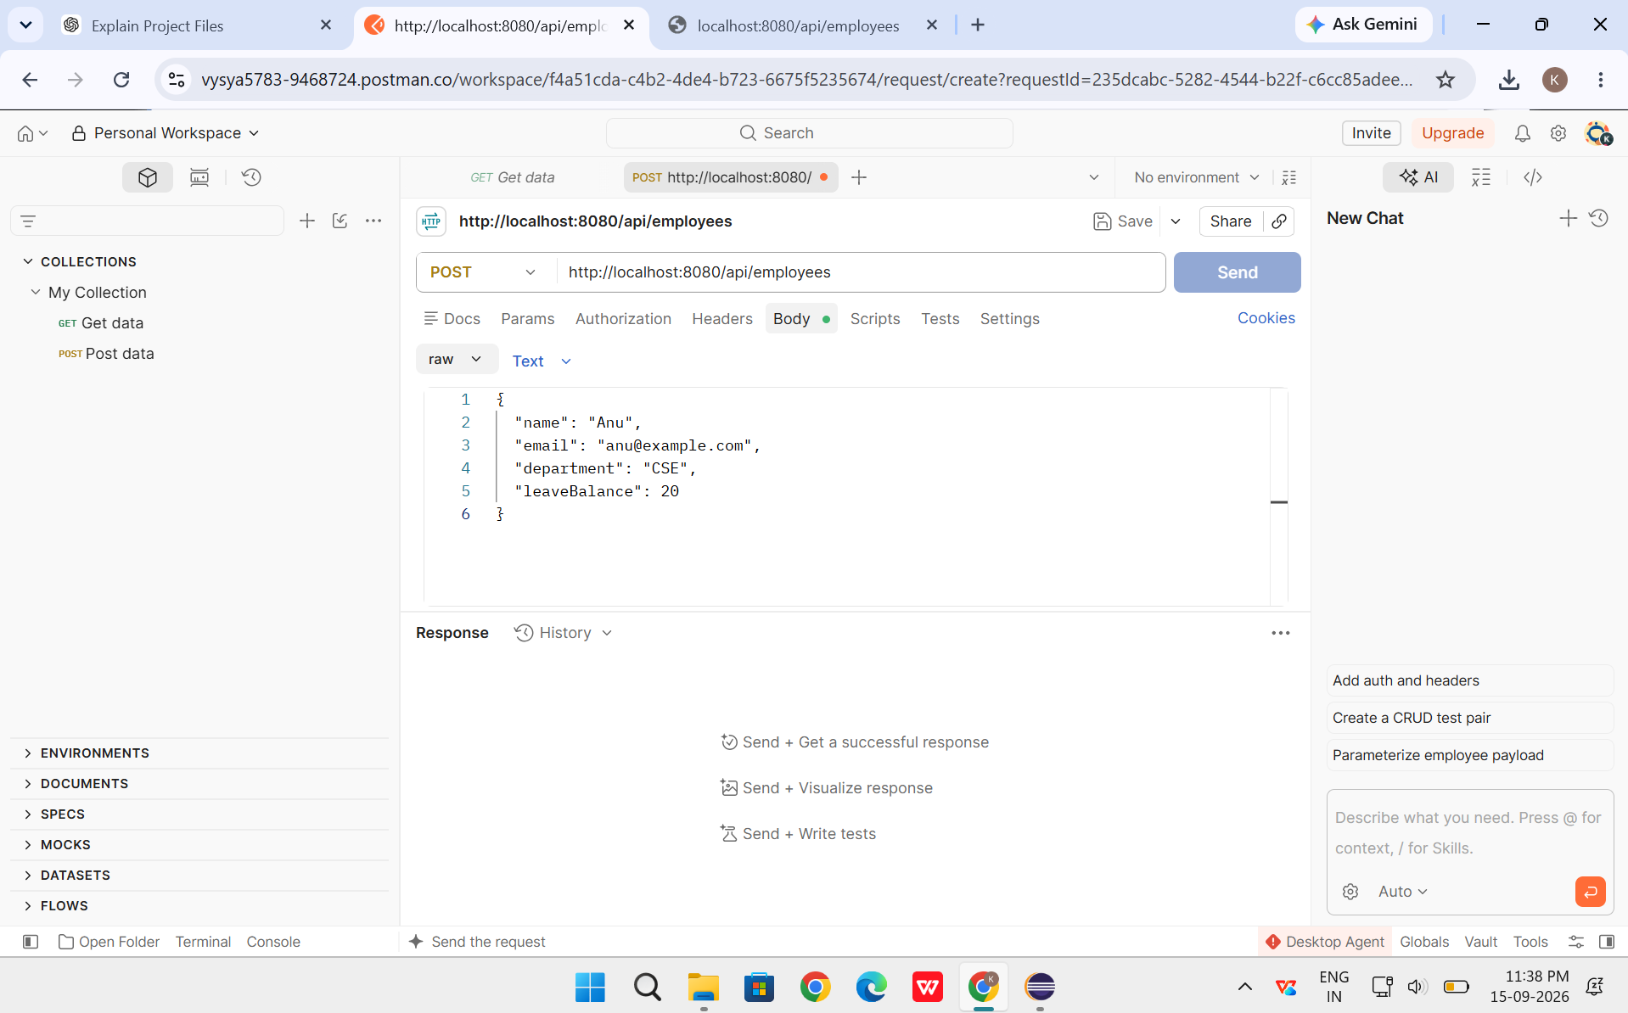

Screenshot 2 – View All Employees
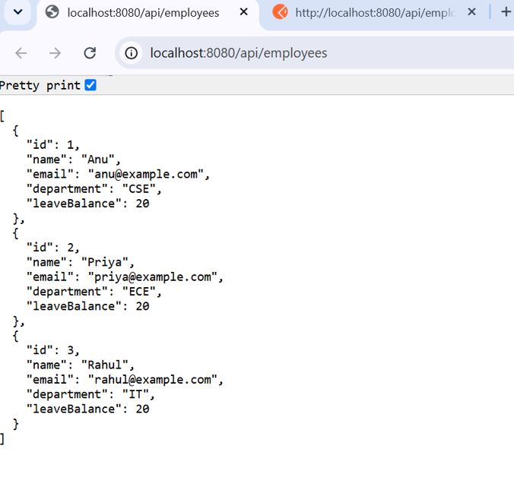

Screenshot 3 – Search Rahul
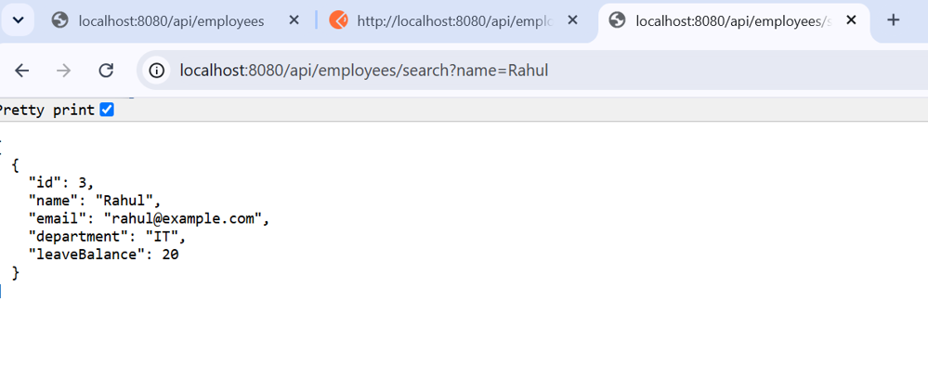

Screenshot 4 – Apply Leave
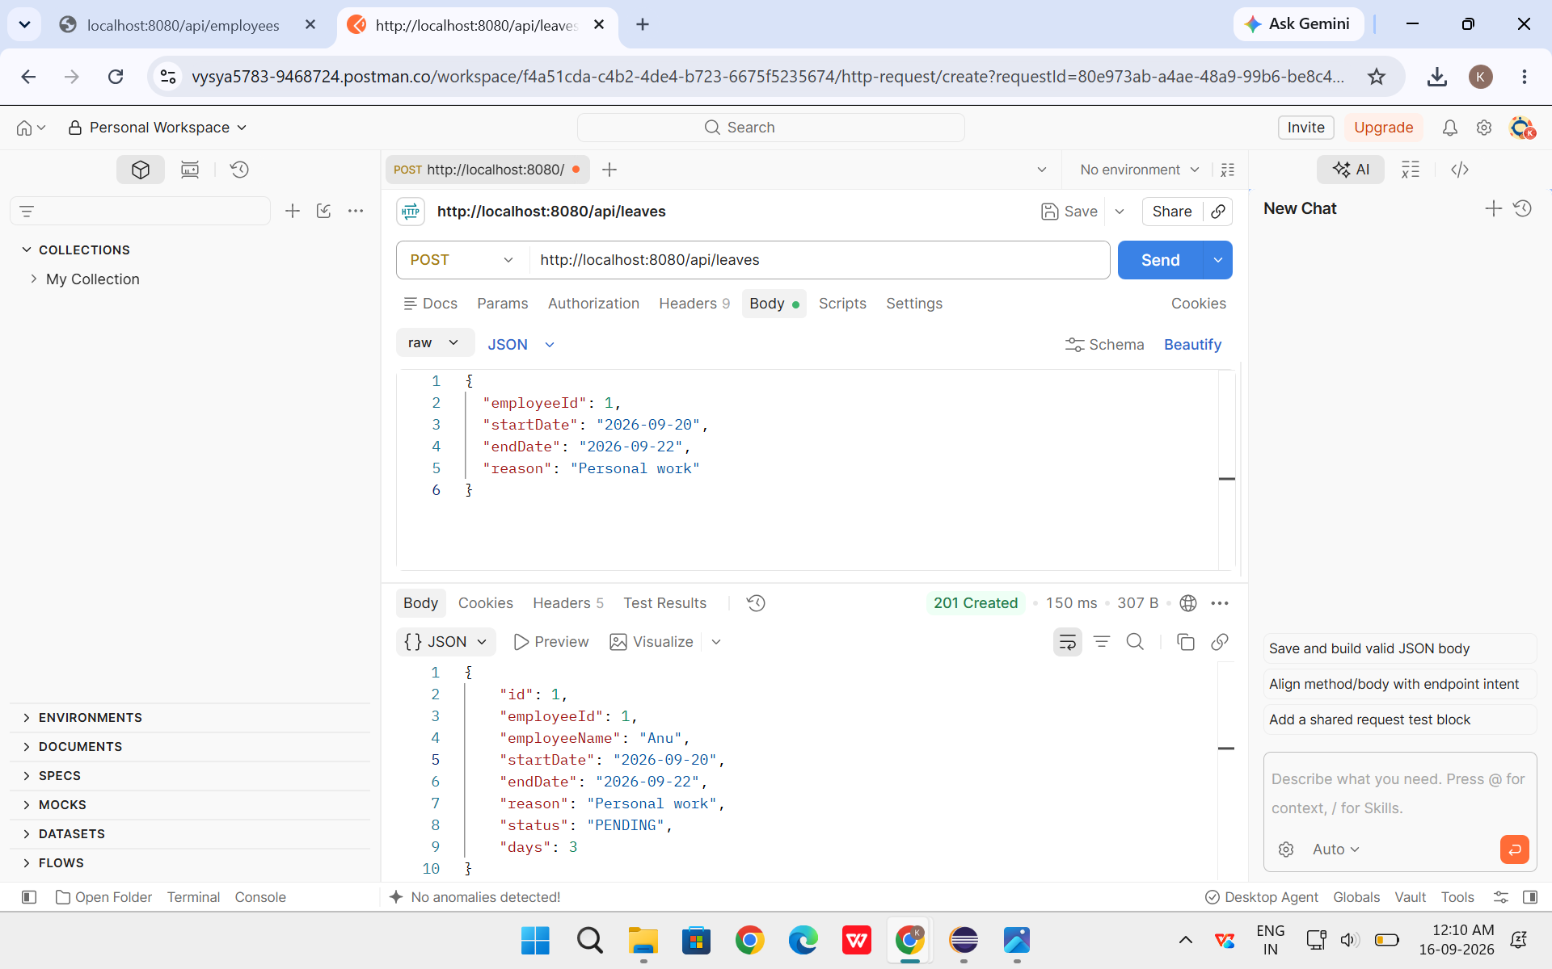

Screenshot 5 – Pending Leave
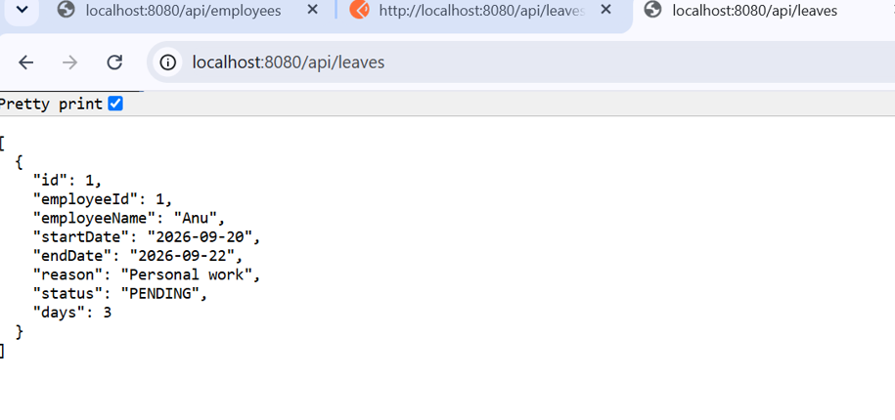

Screenshot 6 – Approve Leave
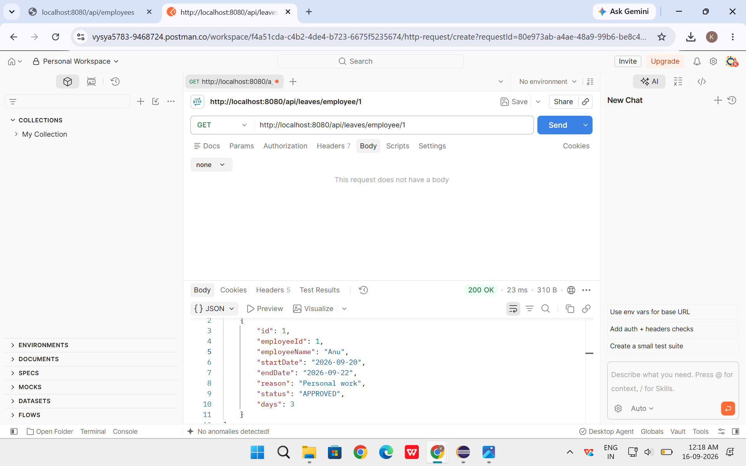

Screenshot 7 – Leave History
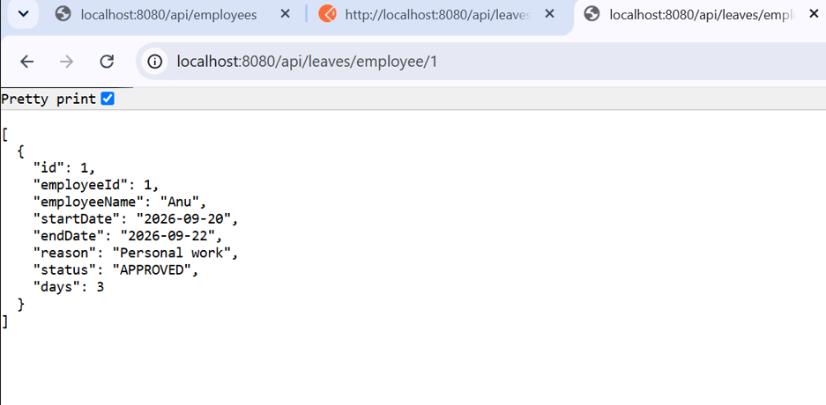

Screenshot 8 – Updated Leave Balance
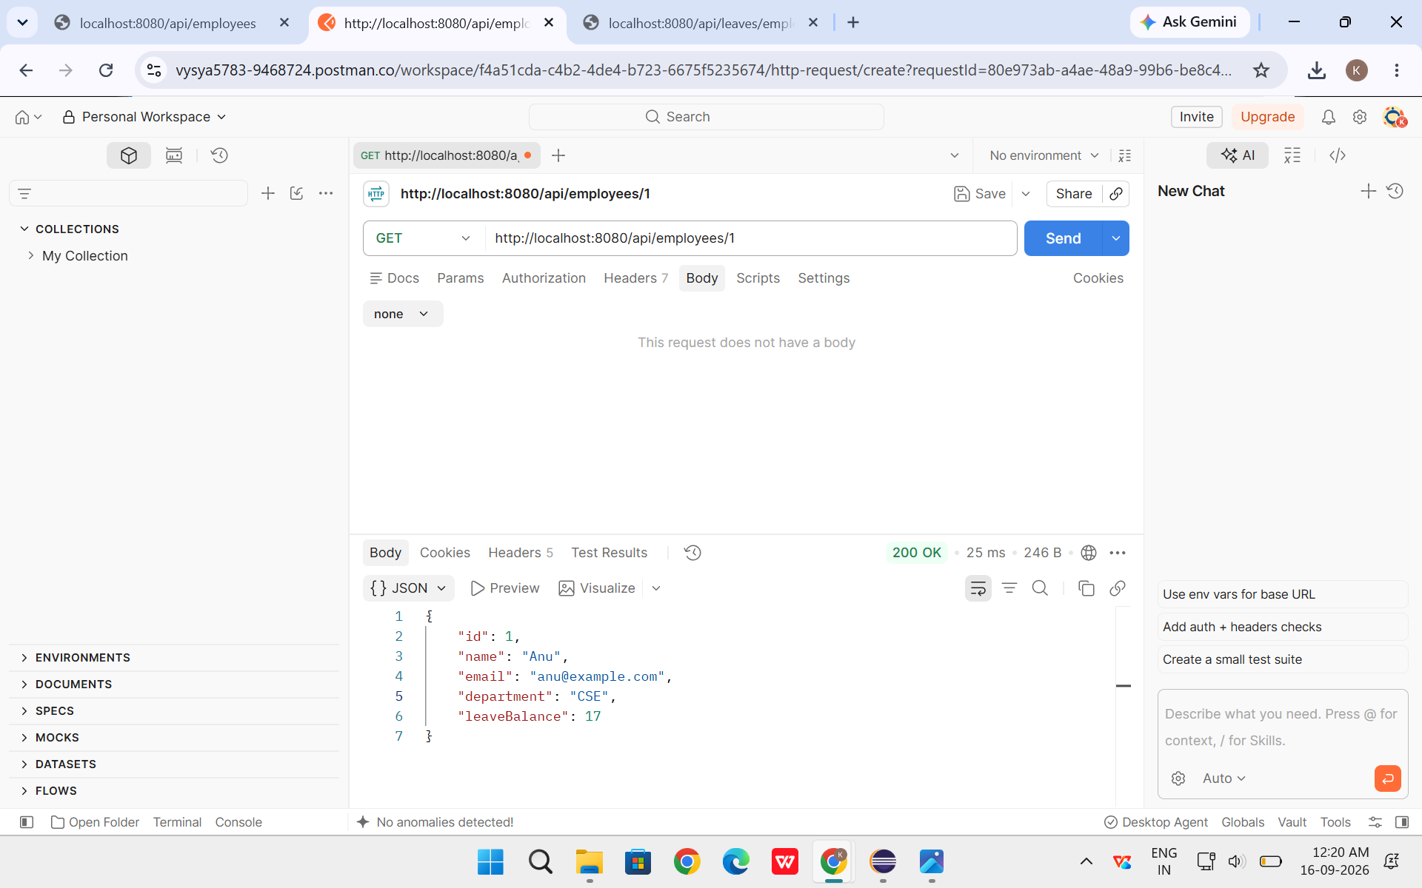
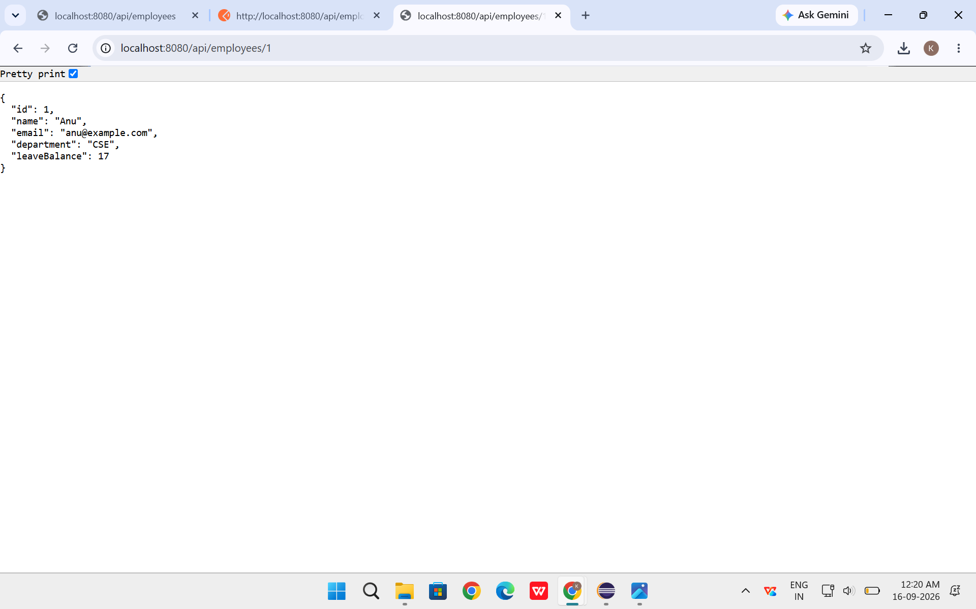

12. Sample Test Data
Employee:
{"name":"Anu","email":"anu@example.com","department":"CSE","leaveBalance":20}
Leave request:
{"employeeId":1,"startDate":"2026-09-20","endDate":"2026-09-22","reason":"Personal work"}
The project calculates the dates inclusively, so this example represents 3 leave days.

13. Project Structure
employee-leave-management/
├── pom.xml
├── README.md
└── src/main/
├── java/com/example/leavemanagement/
│ ├── controller/
│ ├── dto/
│ ├── entity/
│ ├── exception/
│ ├── repository/
│ └── service/
└── resources/
└── application.properties

14. How to Run
- Open the project in Eclipse.
- Run EmployeeLeaveManagementApplication.java.
- Wait until Tomcat starts on port 8080.
- Open Postman and send the API requests.
- Keep Eclipse running while testing because the default H2 database is in-memory.
Base API: http://localhost:8080/api
H2 Console: http://localhost:8080/h2-console

15. Conclusion
The Employee Leave Management System demonstrates a practical leave-management workflow using Java and Spring Boot. The project combines REST APIs, JPA, H2 database operations, validation and exception handling. The complete flow from creating an employee to applying, approving and tracking leave can be tested easily through Postman.

